The AiMH UK IMHDirectoy Application Form

AiMH UK is committed to promoting the importance of infant mental health (IMH) and early relational health, while supporting the ongoing professional development of practitioners, early years workers, educators, students and teams focused on improving outcomes for parents, babies, and toddlers.

The AiMH UK IMH Directory is a new UK platform connecting Infant mental health professionals, practitioners, students, teams with educational institutions and training providers.

It highlights a range of infant mental health training opportunities and academic courses to support practitioners and teams to find CPD training that aligns with their Professional Development Plan (PDP) and to help students explore courses relevant to early years education and learning (0-2).

Universities and Training Providers can list their Infant Mental Health Courses for just £150, which includes:
- A featured listing in our directory.
- Bio and Links to your course.
- A complimentary AIMH UK membership with exclusive benefits*

* Membership benefits include: (https://aimh.uk/membership/)

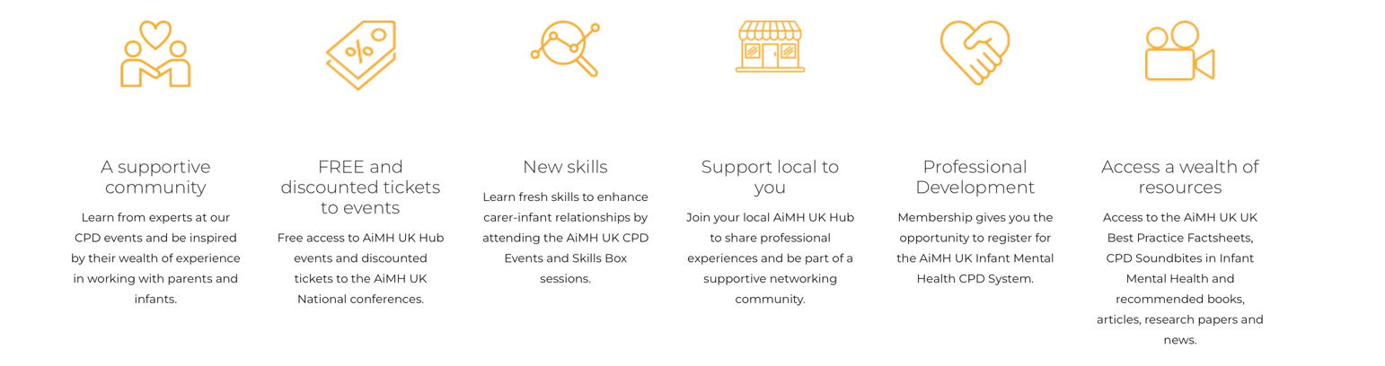

Please complete the application form below and email it to info@aimh.uk, along with a JPEG or PNG file of the logo you would like displayed on the AiMH UK website.

Once received, we will provide payment details and add your information to the IMH Directory.

Many Thanks

Applicant Details
Title |  | Date
First Name |  | Surname
Role
Contact Email
Contact Number
Training Provider Name / University / College Name
Course / Training Title
Bio of Training Course (please try and keep to 50 words)
Link to the Training Provision / Qualification
Did you use the AiMH UK IMH Competency Framework to develop this training provision or course? (Not mandatory)

YES / NO
If yes please give evidence

Accreditation Status (from external organisations, if any)
Are there any pre-requisites for Participation (tick all that apply)
None / Not applicable
Current and direct work with infants and toddlers
Current and direct dyadic work with parents and infants/ toddlers
Regulated Professional
Registered Practitioner
Relevant Qualification (e.g. Diploma in Childcare and Education; Psychotherapist; SCPHN-Health Visitor)
Other, please state:

